RPP Script
Basic Step to Create or Update RPP Record
To create or Update RPP Record follow following steps:
- If Entity is already created and It having action plan record generated but we cannot create RPP for that entity because Product is not updated with that action plan (Since previously there is no Product object associated with action plan we have to map these object to action plan for creating rpp record ) for that use Script No1 .
Note: Refer Script No 1 details is mention in below
- If Entity is already created and it having action plan with product so in this case we have to Create RPP Record for this used Script No 2.
Note: Refer Script No 2 details is mention in below
- When action plan is created then there is also ET created for that action plan. So to create RPP record for that execution tracker we have to first map product with ET as said previously that in previous module of Action plan and Execution tracker we not bind the product object so Script 3 is used to Update Product with ET.
Note: Refer Script No 3 details is mention in below
- When ET record is Created, RPP record is also created but in previous case we updated the ET record with product so we have to update the RPP record so for that use Script No 4.
Note: Refer Script No 4 details is mention in below
- When Execution tracker record is updated with “Closed Status” then we have to Update RPP record for that use Script No 5.
Note: Refer Script No 5 details is mention in below

RPP Script Object Model

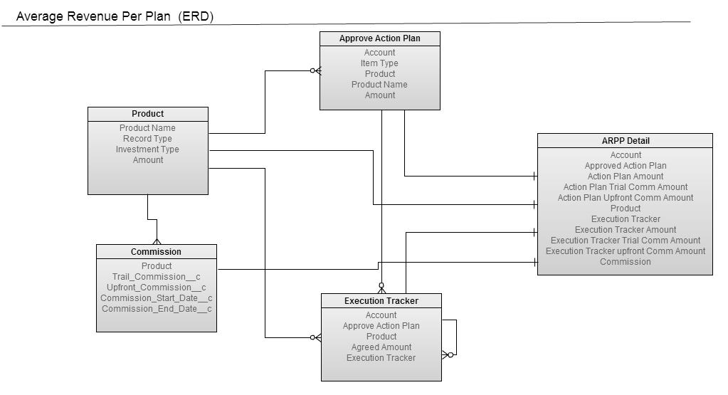

RPP Script Detail
To Create and Update RPP record on existing and new entity we have to write a script.
The Script details are below:
1) First Script is for Updating Action plan record with Product.
- Collect entity and their child record.
- Collect the Action Plan record without Current Running SIP and LUMPSUM
- MAP Action Plan Product with Actual Product Name
- Create map of Item type to Action Plan.
- Retrieve all Products where Product type = Mutual Fund
- Update Action Plan where Item type is SIP/Lumpsum and General Insurance, Life Insurance

2) Second Script to Create RPP for Existing Entity
- Collect entity and their child record.
- Collect the Action Plan record without Current Running SIP and LUMPSUM
- MAP Action Plan Product with Actual Product Name
- Create map of Item type to Action Plan.
- Retrieve all Products where Product type = Mutual Fund
- Create Rpp Record as per Item Type like SIP, Lumpsum, GI and LI

3) Third Script to Update Execution Tracker with Product
- Collect entity and their child record.
- Collect the Execution Tracker record which does not have parent Execution Tracker
- MAP Action Plan Product with Actual Product Name
- Create map of Item type to ETs.
- Retrieve all Products where product type = Mutual fund
- Update ET for with SIP product and Lump sum or Life Insurance and General Insurance.
4) Fourth Script to Update RPP record with ET Product
- Collect entity and their child record.
- Collect the Action Plan record without Current Running SIP and LUMPSUM
- Collect the RPP record from Action plan record
- Collect the Execution Tracker record from Action plan record
- Collect the Rpp Record as per ET Type record like SIP, Lumpsum, General Insurance, and LI.
- Update that RPP record

5) Fifth Script is To Update RPP Calculation
- Collect entity and their child record.
- Collect Approve Action plan record from Execution Tracker Record
- Collect the Rpp record from Action Plan record
- Create Map Approve Action Plan to ARPP Detail
- Collect the Aggregate of Sum of Exection Amount whose status is closed in ET
- Collect the Rpp Record as per Type like SIP, Lumpsum, GI and LI
- Calculate Trail and Upfront Commission for Rpp using ET Product and Commission Record
-Update RPP Record.

